**St Dominic’s**



**Catholic College**

**BYOD Information**

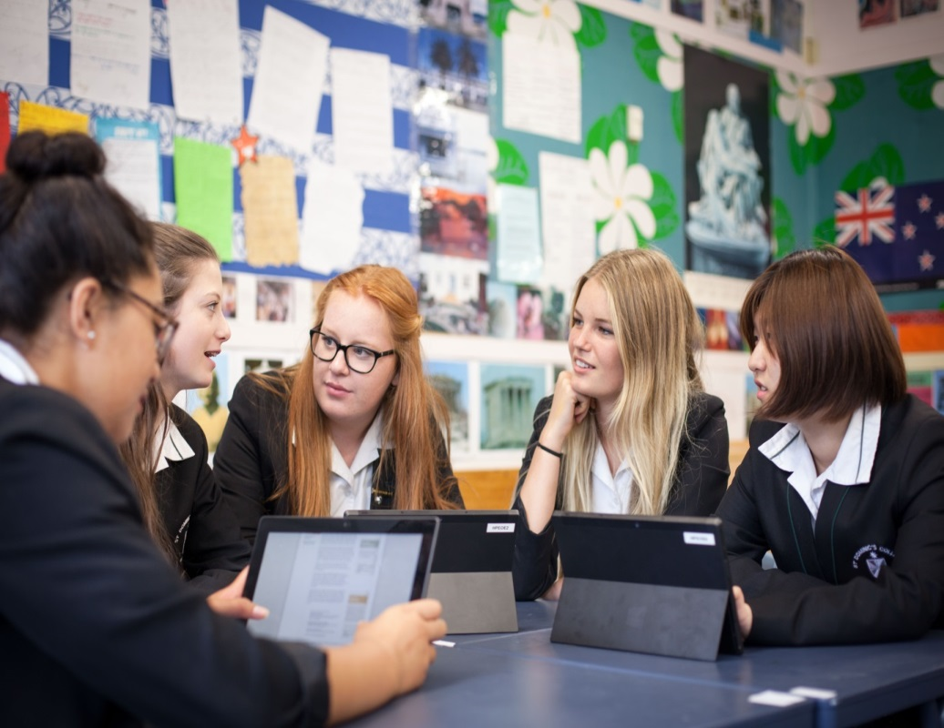

For 2017 it will be expected that all Year 7, 8, 9 and 10 students have a suitable mobile device such as a Chromebook, laptop or netbook, to use in class. Activities in class will often involve use of mobile devices to keep notes, collaborate and access on-line resources. Mobile devices and ICT are now the pens and paper of our children’s world.

**What device should we consider?**

**Minimum Recommended Specifications**

The key requirements are that it should be:

* Light and Portable
* Able to operate GoogleApps. Note that most tablets including iPads are quite limited in this respect so tablets are not acceptable.
* Have a battery that will last at least five hours. (Please note that some Laptops and notebooks fall well short of this. We do not provide charging facilities at school)
* Able to connect to wireless networks and use the Google Chrome browser
* RAM – minimum 2GB (prefer 4GB) for netbooks and laptops.
* At least 16 GB (prefer 32 GB) for tablets.
* Anti-virus software – this is essential to protect the data on the device and to prevent the spread of malware.
* Robust and sturdy enough for school use.
* Under warranty - to ensure that any failure of the hardware or components can be quickly remedied.
* Insured against loss or damage.  Please note that the school will not accept responsibility for any loss or damage occurring at school.
* Have a protective case.

Please note that we will provide help to connect to the school wifi network if needed.  Beyond that students will need to take responsibility for their own devices for problem solving or troubleshooting.  If necessary you will need to refer to a technician or to the supplier where you bought the device.

**Software**

Students will be able to achieve much of what they need to, using online open source tools and GoogleApps.  For this reason it is important that the device has an up-to-date operating system, and a modern browser.

**Accessories**

Students will also need suitable headphones and a solid protective case.

**The advantages of student owned mobile devices**

There are a wide range of advantages to students bringing their own devices to use in class. Most obviously, on-line access allows students to connect with an unlimited selection of resources. Examples of other advantages include:

* + at the most basic level mobile devices allow for quick research to take place without the need for students to be sent to computer rooms.
  + through GoogleApps students can participate in collaborative work on-line both in and out of class time and teachers can provide frequent feedback on the work that they are doing. Students also have the ability to develop on-line folders and exercise books that can never be lost and can be shared with others
  + photos and video recording can be taken to record experiments, speeches, field trips, instructions or anything else for which a record is useful, allowing analysis to take place at a later date.
  + students can access resources and links to useful websites and videos.
  + access to educational games and other learning software such as MyMaths can engage and extend students
  + the ability to draft, redraft and share work at the click of a button
  + giving students the skills to use their technology productively to enhance their learning.

**E-learning examples at St Dominic’s**

**English**

Students are able to write up their research or essays on GoogleDocs and share this with their teacher and other students. The teacher is able to provide quick comments and corrections on-line (rather than waiting to collect the work in), enabling students to develop their writing and get more in-depth feedback. Applications such as Storybird develop a love of writing and fosters a sense of writing for an audience.

**Economics**

Students are able to submit topic ideas to their teacher online and get in-depth feedback. Videos and other resources to support their assessment preparation can be accessed in the one place on Ultranet.

**Mathematics**

Students are working on assessments in GoogleDocs, sharing with their teacher who is able to provide guidance on the direction and depth of their writing. Students are able to access tutorial videos both at home and in class to help them with their work. Maths websites can be accessed at class and at home to provide students with extra practice and to extend our most able students.

**Teacher professional development**

In spite of what students might say, they are not automatic experts in all things tech – we need to teach them how to use the technology *in ways that assist them with their learning*.

Teachers at St Dominic’s are engaging in a variety of training sessions on how they, and their students, can use technology to enhance teaching and learning. We also have a team of ICT Lead Teachers, whose job it is to learn about and advise their departments on e-learning.

**School Infrastructure**

At St Dominic’s we have a modern, high quality information technology infrastructure. The school is now “SNUPed” (School Network Upgrade Programme) meaning that we have wifi in every classroom and a fast, reliable fibre internet connection.

**Google Apps for Education**

Google Apps for Education (GAFE) has been introduced throughout the school to enhance the way we use the technology and share information within and beyond our school community.

Essentially, GAFE is a cloud based learning platform allowing teachers and students to create a range of documents online, email, share calendars and store up to 30 gigabytes of data accessible at home and at school on any device.  GAFE allows us to collaborate and learn more effectively through the use of technology, and offer a range of new learning opportunities for teachers and students.

**What does this mean for my daughter?**

* Students will be given a school Google email account with their own password.
* Your daughter will be able to share documents she is working on with other students and her teachers.
* All student correspondence can be checked by a teacher to ensure that correspondence is school work related only.
* GAFE will act as a platform for teaching students the necessary skills to be responsible digital citizens.
* When students leave St Dominic’s, their Google account will be deleted.

**Facts about Google Apps for Education**

* GAFE is used by many of the world’s leading educational institutions, including universities, secondary and primary schools.  Many New Zealand schools are using GAFE right now.
* GAFE is completely free for schools and does not contain advertising anywhere within it.



**Frequently asked questions**

* **Will my daughter be spending all her time on her device?**

Mobile devices are very useful tools to assist with your daughter’s learning however we know that students learn in many different ways. Mobile devices will be used regularly in class as a part of *the mix* that makes up good teaching and learning.

* **How will my daughter ensure that her mobile device is secure?**

Students are responsible for the safety of any mobile devices brought to school and should keep them with them wherever practicable. For assemblies students are welcome to bring devices with them into the gym so long as they are turned off or store them in a locked classroom. In PE, teachers will provide a secure place for students to store devices during lessons. Parents should ensure that mobile devices are covered by their contents insurance policy and clearly named.

* **How will the school ensure that students are only accessing sites relevant to their learning?**

In class, mobile devices should be used as an integral part of a lesson so teachers will ensure that students are on-task and accessing only relevant material. Student access to the internet is filtered, with social media and inappropriate websites blocked. If you are aware that students are somehow able to access inappropriate sites, please contact the school. Where devices are being used inappropriately in class teachers may temporarily confiscate the device. On-going professional development is being offered to staff in regards to integrating mobile technology effectively into the classroom.

* **How will the school ensure that cyber-bullying is not occurring?**

Access to social media websites via the wifi network is blocked and texting is not permitted in class. Digital citizenry and cyber-responsibility is taught at both Year 7 and Year 9 while all students sign a new ICT Acceptable Use Agreement at the beginning of each year which specifically covers cyber-bullying and harassment. Any cyber-bullying will be dealt with under the College’s anti-bullying policies.

* **Won’t BYOD create inequality in the classroom?**

We acknowledge that there is a considerable cost involved in requiring students to bring their own devices to school to use and that this may be difficult for some families, however we believe that the benefits for students are worth it. We will be negotiating with local retailers so keep an eye on College publications for finance deals which should make things more affordable. If your family is having difficulty in being able to provide a device for your daughter, please let the school know.

* **What happens if my daughter’s device breaks or fails?**

Check with your retailer about after sales service *before* you buy – most should provide a replacement device while repairs are taking place – if they do not then it may pay to think again.

Carefully consider the value of a warranty – the Consumer Guarantees Act ensures that devices should be fault free for a “reasonable” period of time however warranties that cover longer than 18 months and for user caused issues, may be worth consideration. Please ensure that your daughter’s device is covered by Contents insurance.

* **Do I need to get Microsoft Office installed on my daughter’s device?**

No. Students are able to use GoogleApps (provided free and on-line) which include the ability to word process, create spreadsheets and create presentations. While not as powerful as Office, these should be ample for your daughter’s work in the junior school.